1

**School Management System for LEARNERS**

Bipasha Lamsal

B.Sc. (Hons.) Computing, Softwarica College of IT and E-commerce, Coventry University

ST4008CEM Computing Activity Led Learning Project 1

Giriraj Rawat

Feb 21, 2023

2

**Table of contents**

School Management System for LEARNERS…………………………………………………....4

Introduction……………………………………………………………………………………….4

Login page………………………………………………………………………………………...4

Registration page………………………………………………………………………………….7

Main Home page………………………………………………………………………………….8

Version Control…………………………………………………………………………………..10

Conclusion……………………………………………………………………………………….11

3

**Table of Figures**

Figure 1……………………………………………………………………………………………………………………………………..4

Figure 2……………………………………………………………………………………………………………………………………..5

Figure 3……………………………………………………………………………………………………………………………………..6

Figure 4……………………………………………………………………………………………………………………………………..7

Figure 5……………………………………………………………………………………………………………………………………..

Figure 6……………………………………………………………………………………………………………………………………..

Figure 7……………………………………………………………………………………………………………………………………..

Figure 8……………………………………………………………………………………………………………………………………..

Figure 9……………………………………………………………………………………………………………………………………..

4

**School Management System for LEARNERS**

**Introduction**

School Management System (LEARNERS) is a management system which guarantees the better interaction between students and teachers. The main objective of this project of mine which is front end is to develop a modest, user-friendly and cooperative **‘Login, Registration and Dashboard’** page for the students and teachers in School Management System using Python’s Tkinter tools.

This system provides the school event and all the activity related information, show latest news on the notices part of the system. It also provides the facility for sending the message via the tickets regarding your concern about anything that you have towards the school.

**Login page**

It helps in the login of the students and teachers. New students and teachers who don’t have their account can be registered via **“Signup”**. You can enter your registered username and password and get access to the dashboard or home page of the system.

Through valid data entry, it allows a platform to securely login to user’s account. Login pages are shown in Figure 1 and Figure 2 represents the code of Login page.

Figure 1

Login page

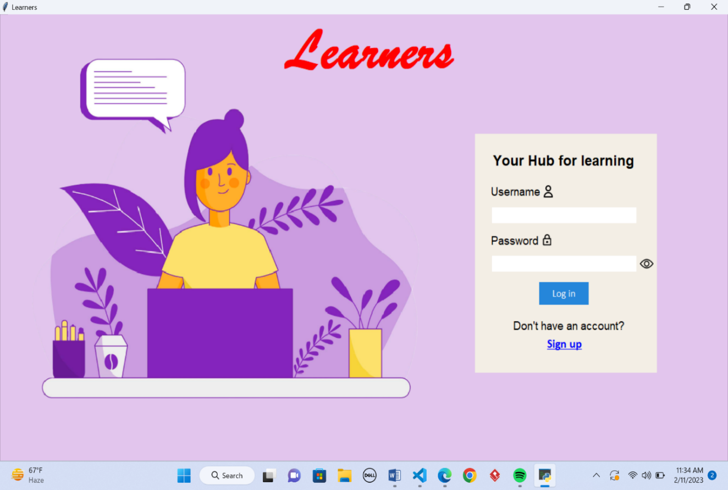

5

Figure 2

Login code

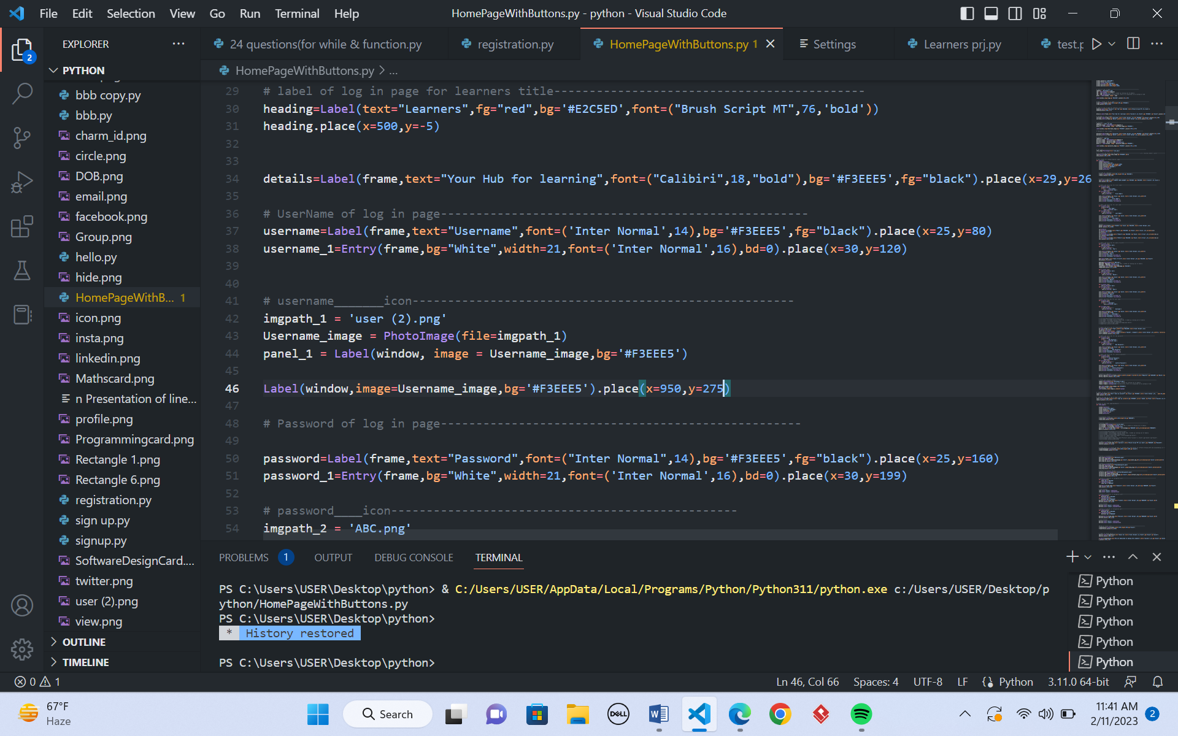

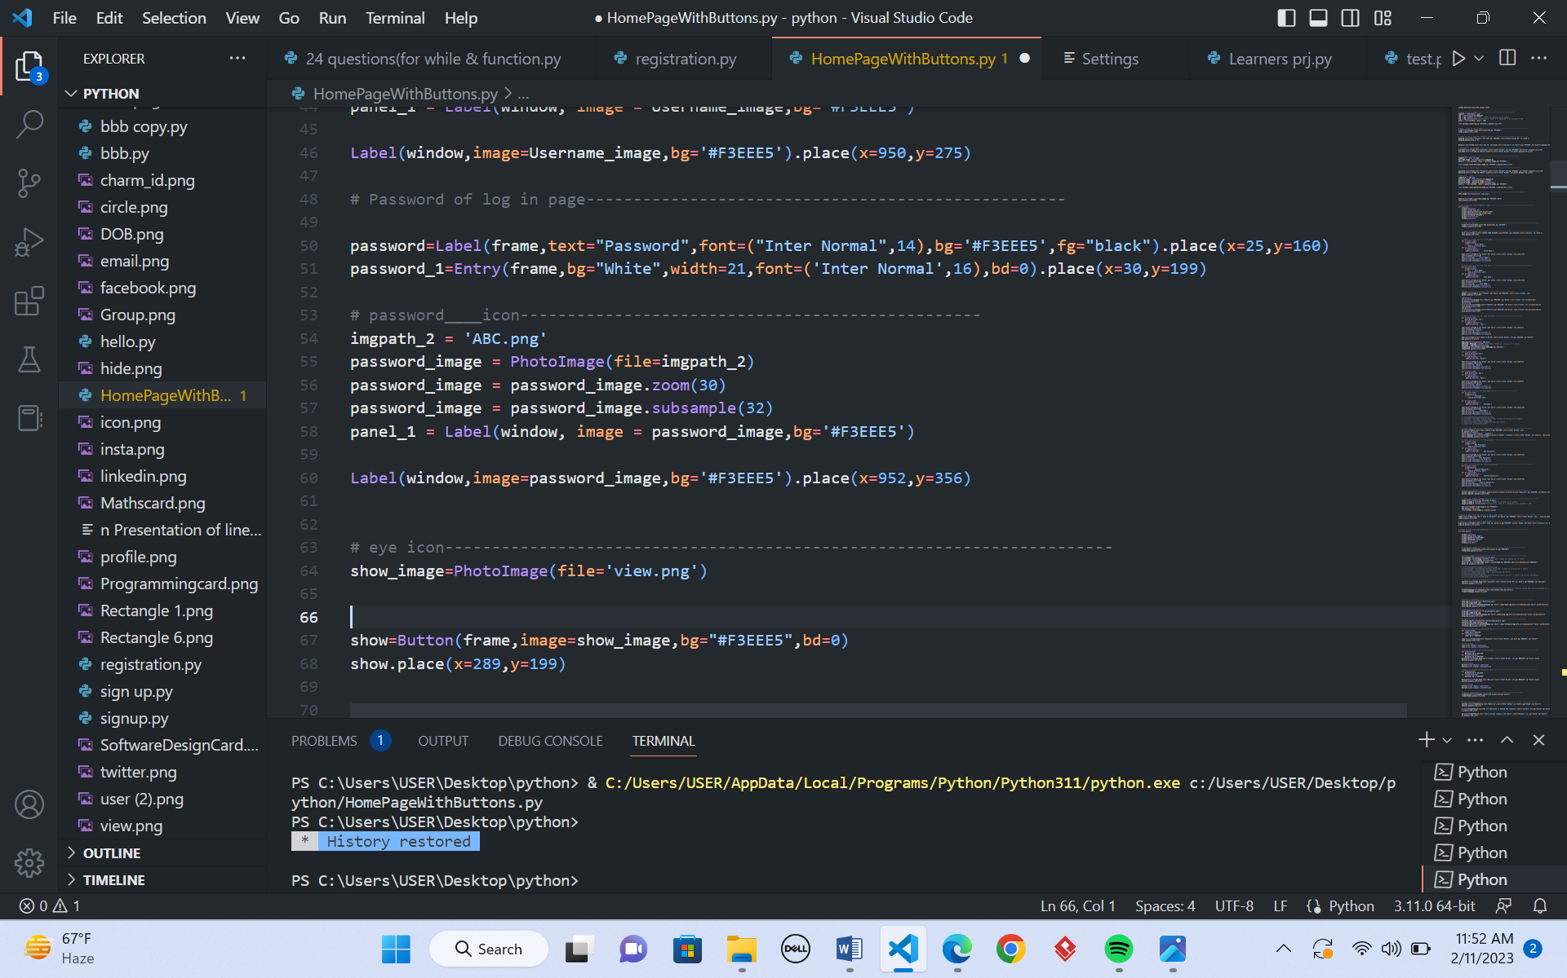

6

**Registration page**

A registration page includes the field where a user will input the data and submit it. After submitting it, you will be signed up in the system and then you can use the system with its full functionality. After you fill the data in the given entry box and enter the register button, then you will have access to use the function of the system. Figure 3 represent the registration page and Figure 4 includes its code.

Figure 3

Registration page

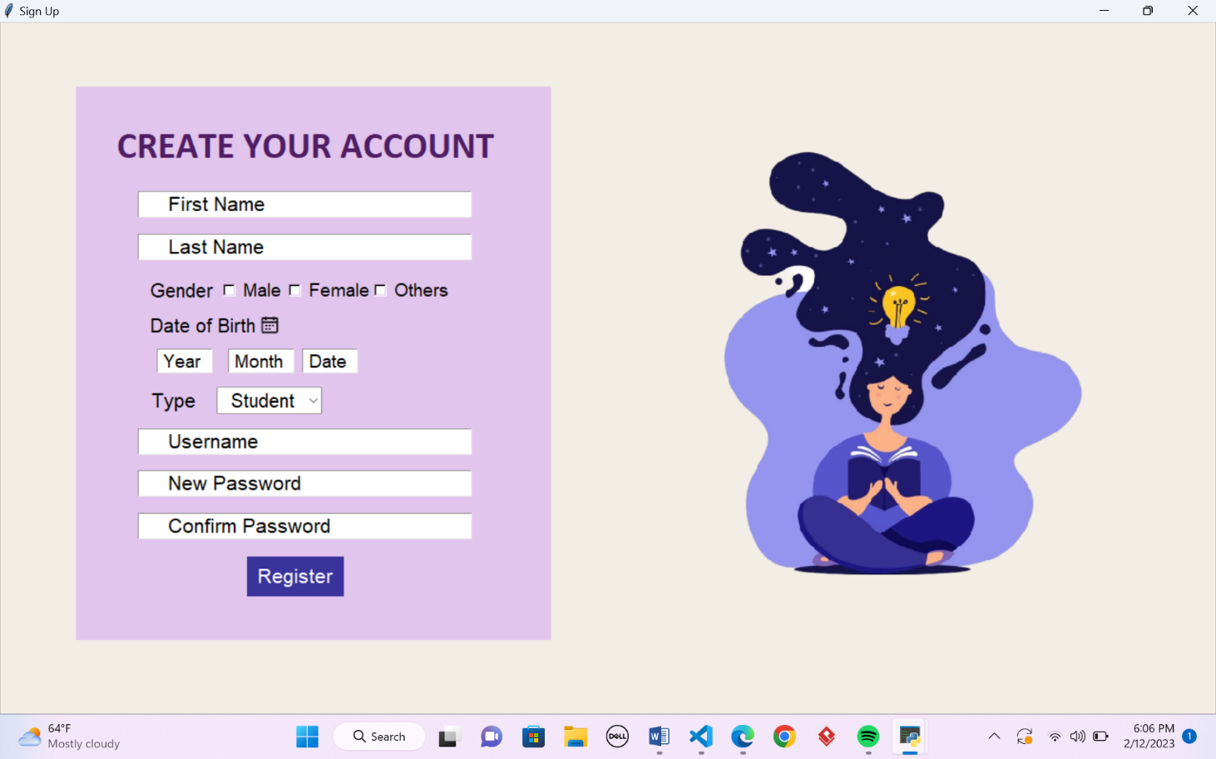

7

Figure 4

Registration code

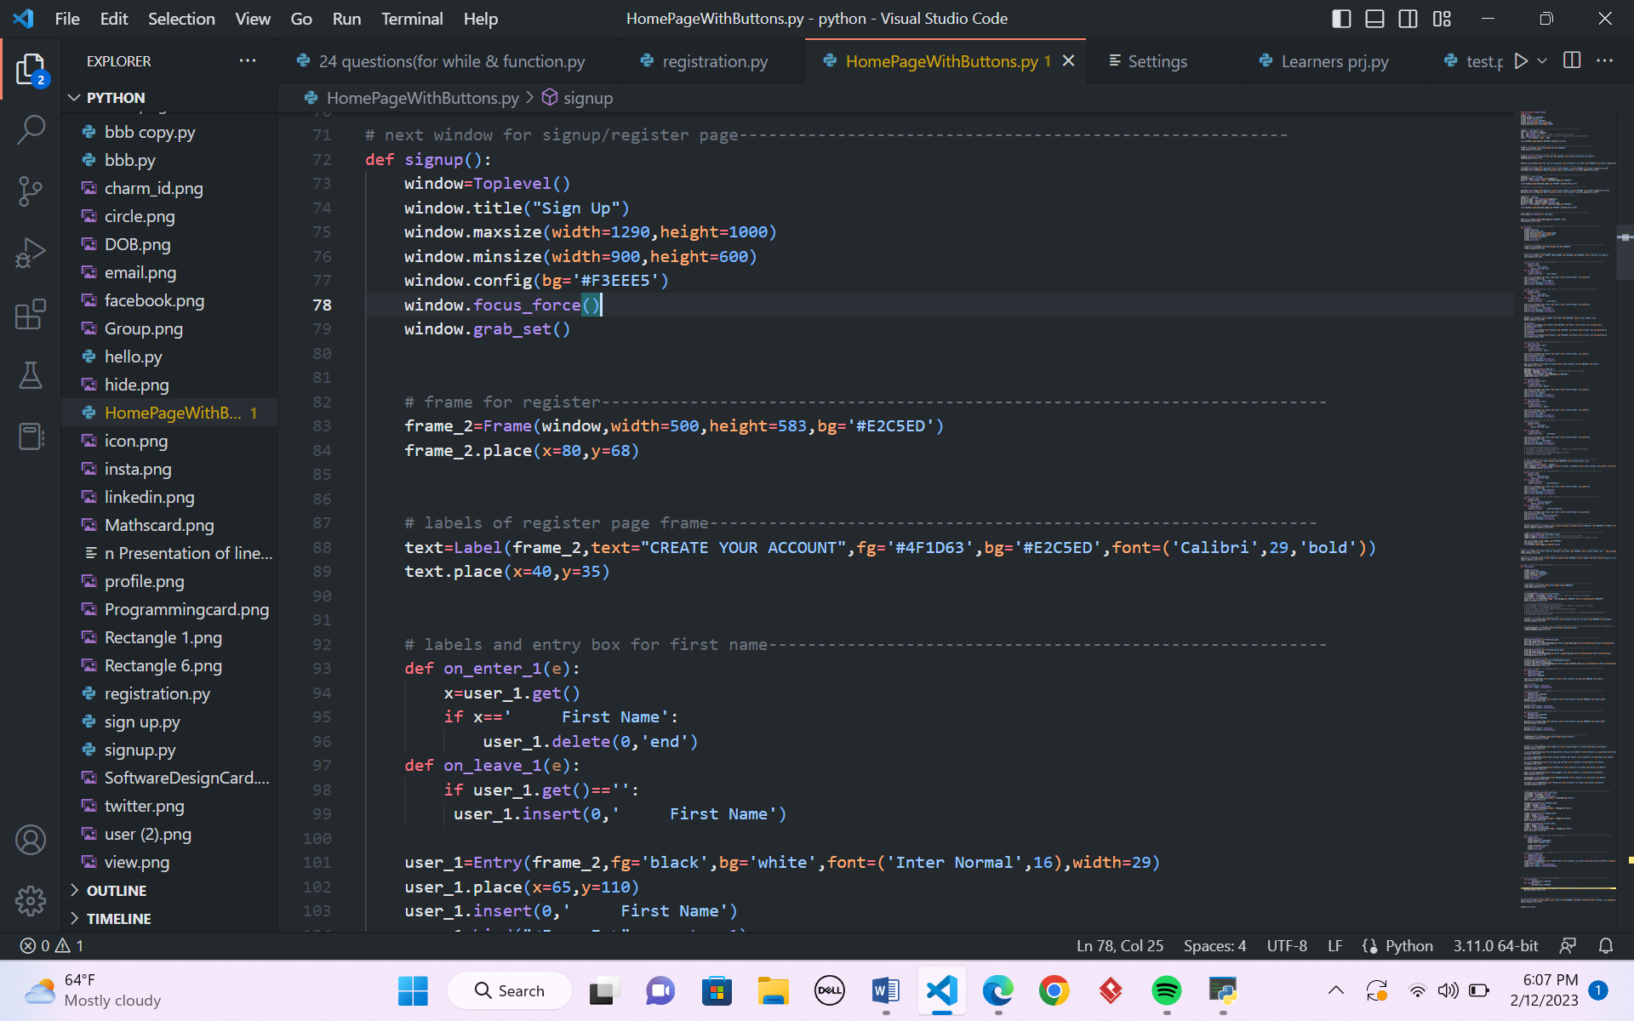 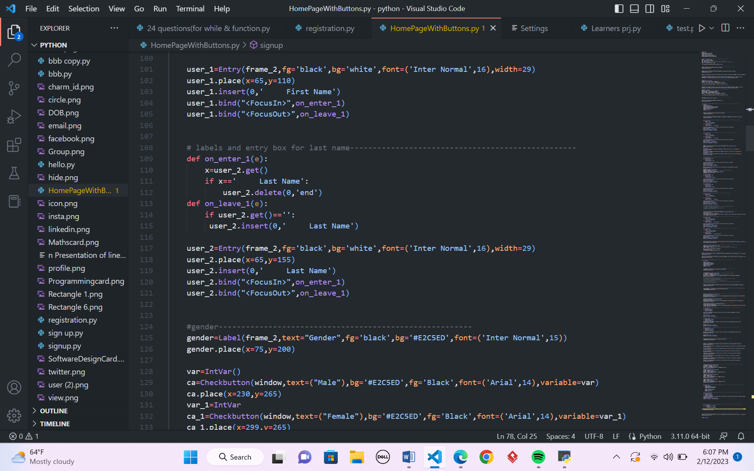

8

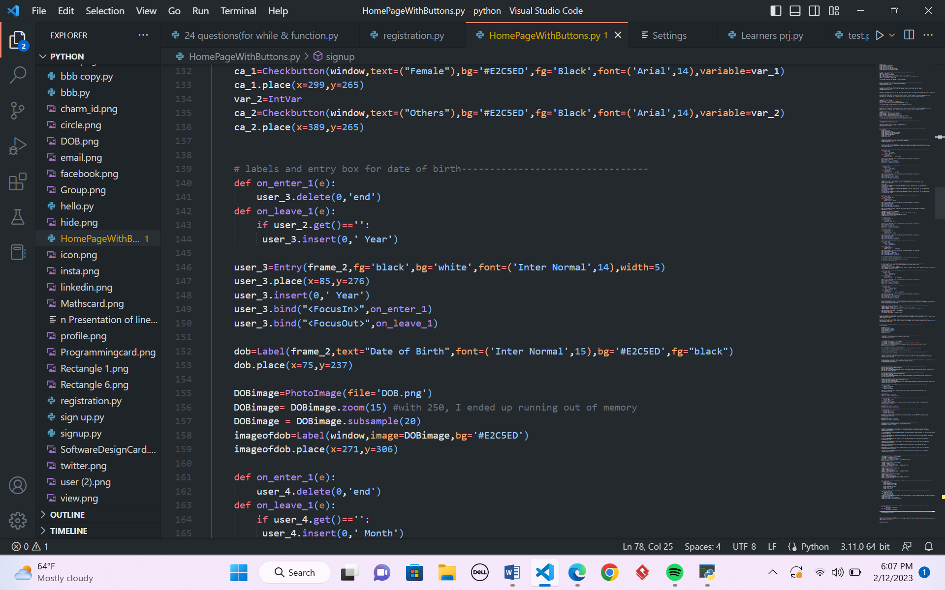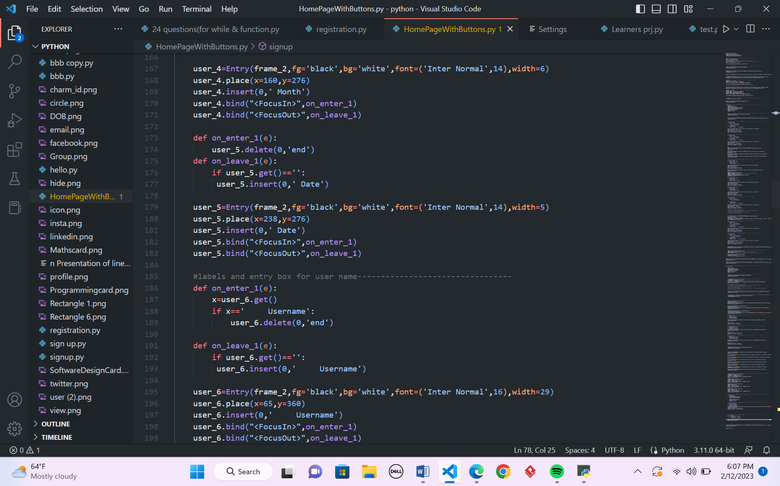

9

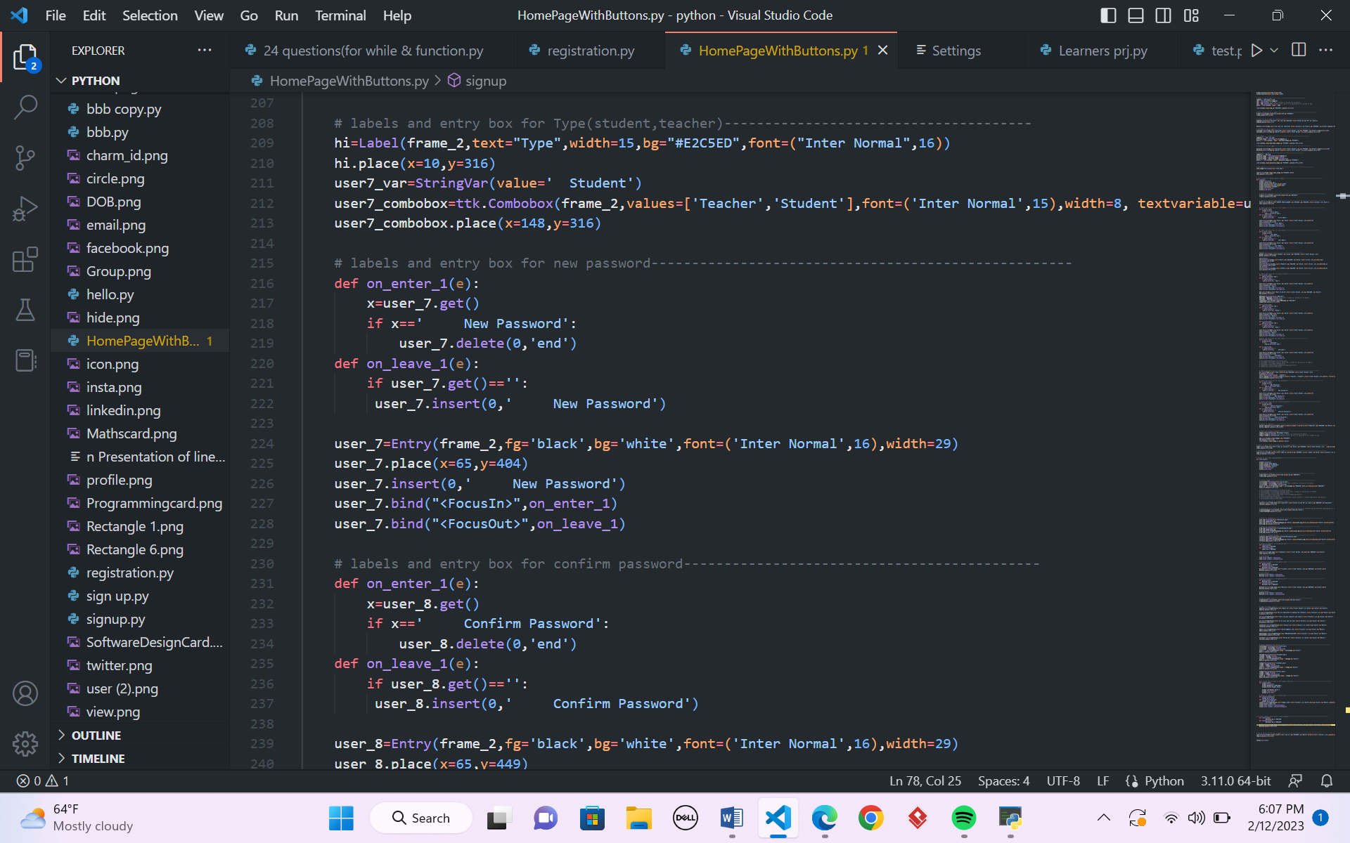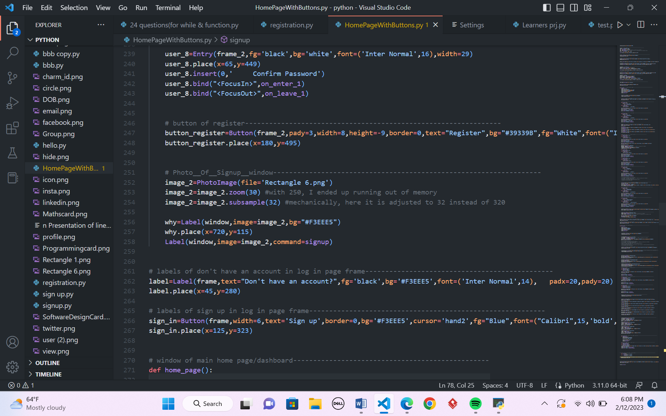

10

**Main home page**

Version Control

Gituhub:

11

**Conclusion**

Concepts of Tkinter tools taught in classroom were fully utilized to design an attractive GUI for data-entry according to SRS document and prototype. Science has proved that colours influence mood. I want my users to be in good mood while using this POS, so I focused on combining simplicity with aesthetics, and popping bright-warm colours to counter outdated classic POS-designs in market. The GUI is simple enough for connection to backends. I chose GUI because of my expertise in graphics. Due to inexperience as first-timer in coding, many individual UI(s) for secure login expended lots of my time plus effort. Though tiring, I recognized my shortcomings; consulted internet, instructors and concerned books for help. In future projects, research on functionalities integration in single interface will be prioritized. I will amass experience by coding more GUI in my daily life. This endeavour to learn by continuous practice without being discouraged is my strength. This project taught me: A working software is a good software, however a working software focusing user is a better software. Creation of this software enriched my experience, knowledge, teamwork, and critical thinking. It has validated practicality of theoretical knowledge in IT field, enlightening me that problem solving means thinking smarter to find alternative solutions when one method doesn’t work